RAG - Ingestion
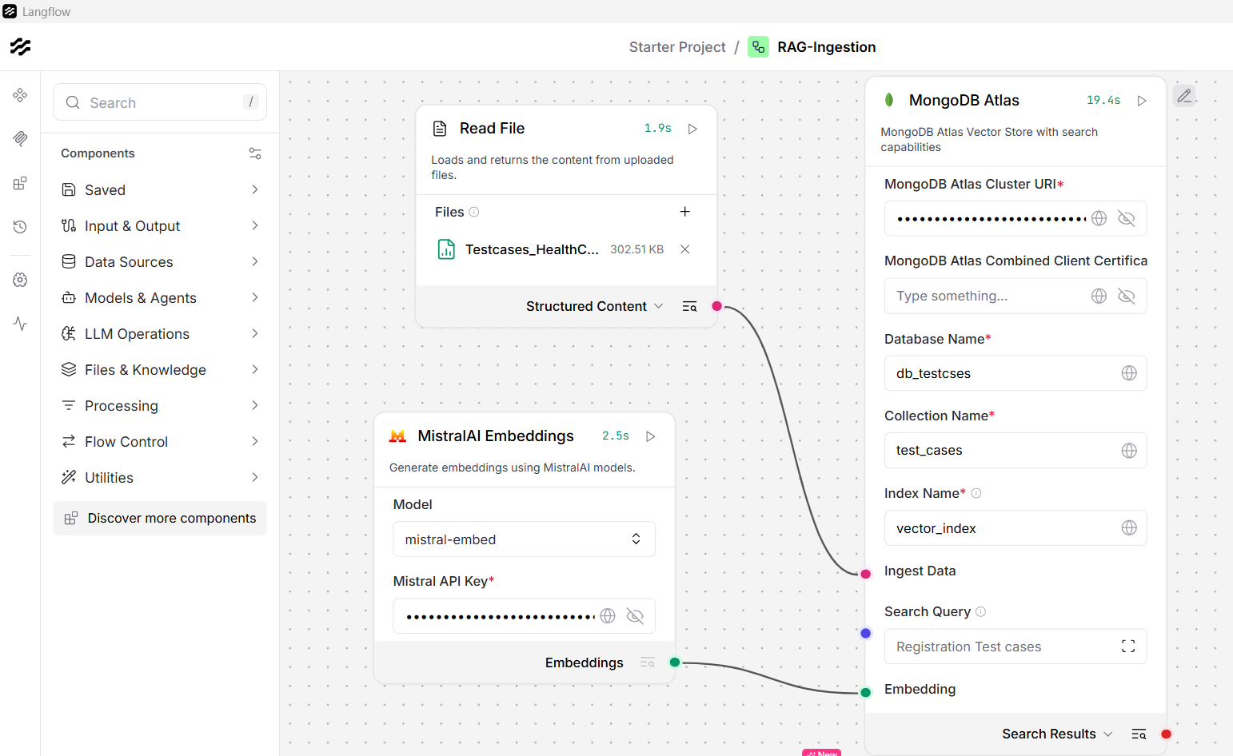

Output for 4 TCs
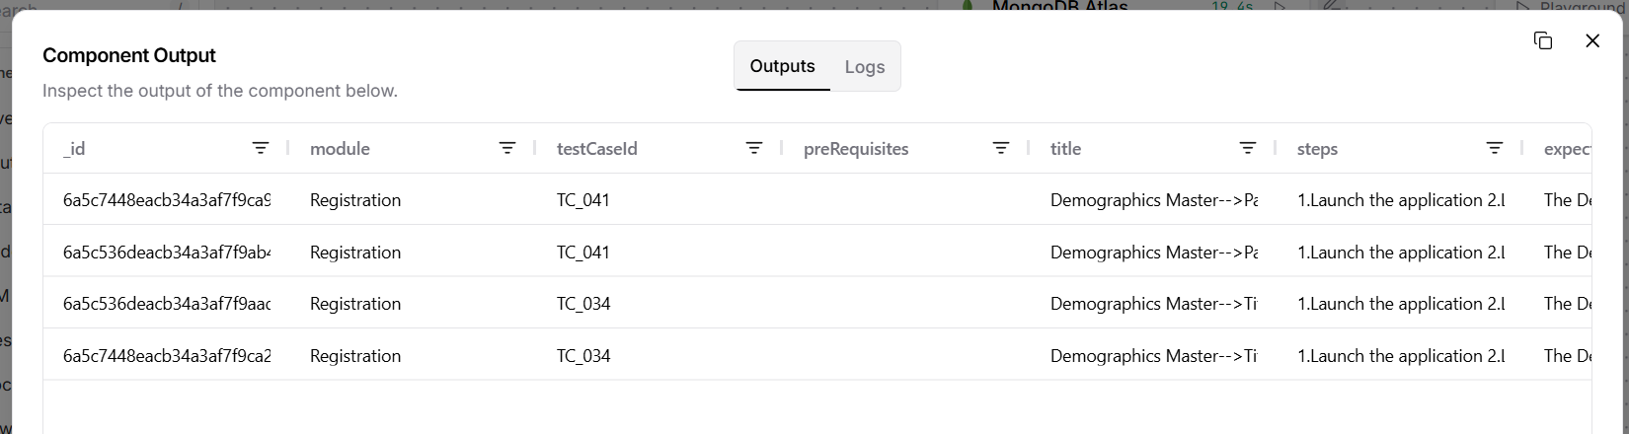

Output for 8 TCs
